PROJECT REPORT

ELECTRONIC VOTING SYSTEM USING BLOCK CHAIN

BACHELOR OF ENGINEERING

In

ELECTRONIC AND COMMUNICATION ENGINEERING

Team Id: NM2023TMID01563

Submitted by:

S.SARANRAJ- 420420106014

S.YUVARAJ-42042006019

V.MOTHAGAMANIKANDAN-420421006009

1. **Introduction:**

Electoral integrity is essential not just for democratic nations but also for state voter’s trust and liability. Political voting methods are crucial in this respect. From a government standpoint, electronic voting technologies can boost voter participation and confidence and rekindle interest in the voting system. As an effective means of making democratic decisions, elections have long been a social concern. As the number of votes cast in real life increases, citizens are becoming more aware of the significance of the electoral system . The voting system is the method through which judges judge who will represent in political and corporate governance. Democracy is a system of voters to elect representatives by voting . The efficacy of such a procedure is determined mainly by the level of faith that people have in the election process. The creation of legislative institutions to represent the desire of the people is a well-known tendency. Such political bodies differ from student unions to constituencies. Over the years, the vote has become the primary resource to express the will of the citizens by selecting from the choices they made .

**1.1** **Project Overview:**

Online voting is a trend that is gaining momentum in modern society. It has great potential to decrease organizational costs and increase voter turnout. It eliminates the need to print ballot papers or open polling stations—voters can vote from wherever there is an Internet connection. Despite these benefits, online voting solutions are viewed with a great deal of caution because they introduce new threats. A single vulnerability can lead to large-scale manipulations of votes. Electronic voting systems must be legitimate, accurate, safe, and convenient when used for elections. Nonetheless, adoption may be limited by potential problems associated with electronic voting systems. Blockchain technology came into the ground to overcome these issues and offers decentralized nodes for electronic voting and is used to produce electronic voting systems mainly because of their end-to-end verification advantages. This technology is a beautiful replacement for traditional electronic voting solutions with distributed, non-repudiation, and security protection characteristics. The following article gives an overview of electronic voting systems based on blockchain technology. The main goal of this analysis was to examine the current status of blockchain-based voting research and online voting systems and any related difficulties to predict future developments. This study provides a conceptual description of the intended blockchain-based electronic voting application and an introduction to the fundamental structure and characteristics of the blockchain in connection to electronic voting. As a consequence of this study, it was discovered that blockchain systems may help solve some of the issues that now plague election systems. On the other hand, the most often mentioned issues in blockchain applications are privacy protection and transaction speed. For a sustainable blockchain-based electronic voting system, the security of remote participation must be viable, and for scalability, transaction speed must be addressed. Due to these concerns, it was determined that the existing frameworks need to be improved to be utilized in voting systems.

1.2 Purpose:

Electronic voting technology intends to speed the counting of ballots, reduce the cost of paying staff to count votes manually and can provide improved accessibility for disabled voters. Also in the long term, expenses are expected to decrease.[[6]](https://en.wikipedia.org/wiki/Electronic_voting#cite_note-auto-6) Results can be reported and published faster.[[7]](https://en.wikipedia.org/wiki/Electronic_voting#cite_note-7) Voters save time and cost by being able to vote independently from their location. This may increase overall voter turnout. The citizen groups benefiting most from electronic elections are the ones living abroad, citizens living in rural areas far away from polling stations and the disabled with mobility impairments.

**2. LITERATURE SURVEY:**

**2.1 Existing problem:**

As the world watched the electoral drama unfold in Florida at the end of 2000, people started wondering, “Wouldn’t all our problems be solved if they just used Internet Voting?”. People all over the world soon started taking a hard look at their voting equipment and procedures, and trying to figure out how to improve them [1]. There is a strong inclination towards moving to Remote Internet Voting – at least among the politicians – in order to enhance voter convenience, increase voter confidence and voter turnout. However, as will be seen later in this paper, there are serious technological and social aspects that make Remote Internet Voting infeasible in the visible future. Therefore, many technologists have suggested that remote poll-site electronic voting, where the voter can vote at any poll-site (not only his home county poll-site), seems to be the best step forward as it provides better voter convenience, but at the same time, does not compromise security. This paper presents a survey of the state of the art in Electronic Voting, including the various works done in Internet Voting (and the arguments against its use), as well as in electronic poll-site voting.

Electronic voting refers to the use of computers or computerized voting equipment to cast ballots in an election. Sometimes, this term is used more specifically to refer to voting that takes place over the Internet. Electronic systems can be used to register voters, tally ballots, and record votes

In “Electronic Voting” , Rivest addresses some issues like the “secure platform problem” and the (im)possibility of giving a receipt to the voter. He also provides some personal opinions on a host of issues including the striking dissimilarity between e-commerce and e-voting, the dangers of adversaries performing automated, wide-scale attacks while voting from home, the need for extreme simplicity of voting equipment, the importance of audit-trails, support for disabled voters, security problems of absentee ballots, etc.

* 1. **References**

1. “Voting After Florida: No Easy Answers,” Lorrie Faith Cranor, December 2000.
2. “Electronic Voting,” Encyclopedia of Computers and Computer History, prepared by

Lorrie Faith Cranor and edited by Raul Rojas, published by Fitzroy Dearborn, 2001.

1. “Voting – What is, What Could be,” Caltech/MIT Voting Technology Project (VTP)

Report, July 2001.

1. “A Modular Voting Architecture (“Frogs”),” Shuki Bruck, David Jefferson, and Ronald L. Rivest, August 2001.
2. “Comments of Professor Ronald L. Rivest”, Caltech/MIT VTP Press Conference, July 16,2001.
3. “Testimony given before the U.S. House Committee on Administration”, Ronald L. Rivest,May 24, 2001, “Electronic Voting,” Ronald L. Rivest, Technical Report, Laboratory for Computer

Science, Massachusetts Institute of Technology.

1. “Report of the National Workshop on Internet Voting: Issues and Research Agendas,”Internet Policy Institute, Sponsored by the National Science Foundation, Conducted incooperation with the University of Maryland and hosted by the Freedom Forum, March2001.

9. “A Report on the Feasibility of Internet Voting,” California Internet Voting Task Force,

January 2000.

1. “Appendix A: Technical Committee Recommendations,” California Internet Voting TaskForce, January 2000.
   1. **Problem Statement Definition:**

The basic methodology as applied to online voting system would involve giving voter realistic voting task to accomplish using a variety of ballot design. A regroups methodology is used to sample variable aspects of the system, such as vectors and ballots. The sample is constructed so as to provide a statistical basic for generalization from the sample to the populations they representing voting task performance is measured using variable such as accuracy time and workload.

In online voting mechanism each voter receives a unique ballot code. The ballot code has an arbitrary length and is generated randomly to help prevent manipulation. Online voting system mails virtual ballot papers, including the ballot code, to the voters to the voting server.

**3.IDEATION & PROPOSED SOLUTION:**

**3.1 Empathy Map Canvas:** The first stage, empathise, focused on gaining an empathic understanding of users' needs and challenges. A number of activities were employed at this initial stage. A substantial amount of information was gathered at this stage to use during the next stage of the design process and develop the best possible understanding of the users

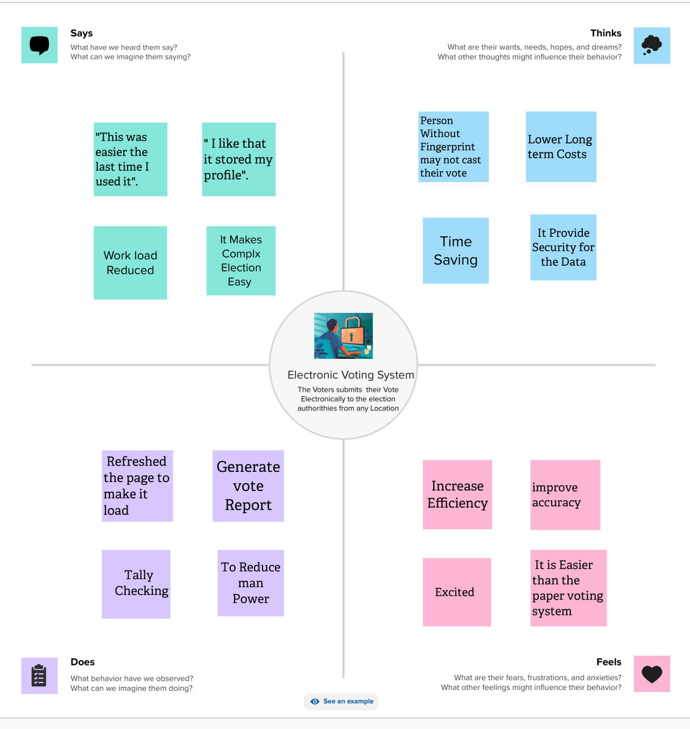

**3.2 Ideation & Brainstorming:**

Following the warm-up activities in which participants had by then become better acquainted with the software, participants were directed to the primary online workshop activity which included 5 separate question boards of ‘How might we…?’ questions, similar to the face-to-face workshop. Fewer questions (5 as opposed to 8 in comparison with the face–to–face workshop) were asked in the virtual workshops due to stricter time constraints. There was also a consensus between project members that more than 5 questions may risk participant disengagement due to a lack of face-to-face contact. The ‘How might we…?’ question was outlined at the top of the board and sticky notes were placed within the board to facilitate participant's answers.

**Step-1: Team Gathering, Collaboration and Select the Problem Statement**



**Step-2: Brainstorm, Idea Listing and Grouping:**

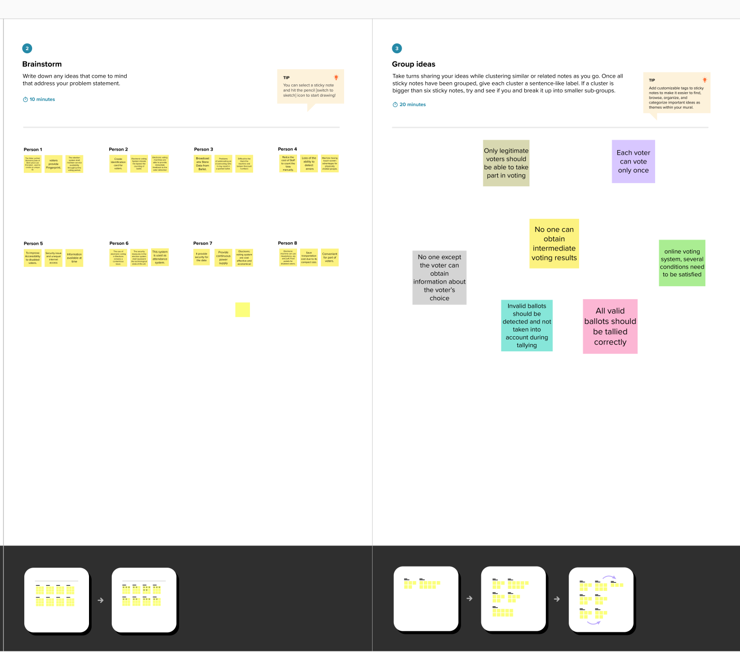

**Step-3: Idea Prioritization:**

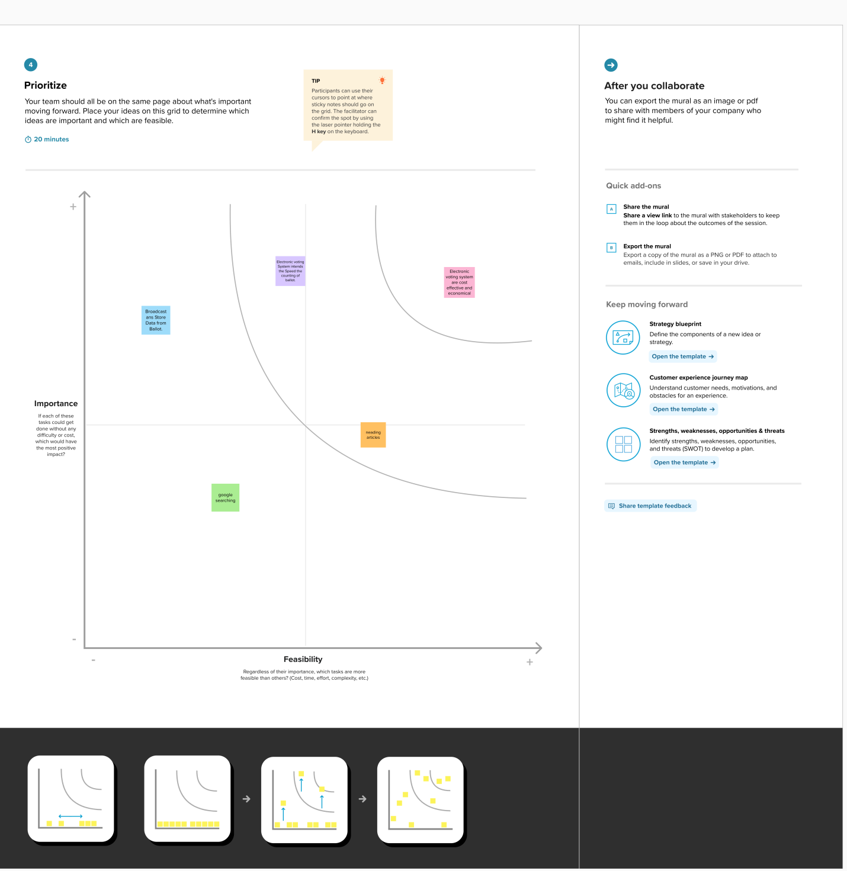**4.REQUIREMENT ANALYSIS:**

**4.1 Functional requirement:**

1. Mobility: The voter should not be restricted to cast his ballot at a single poll-site at his home precinct. • Realistic: He shall be able to vote from any poll-site within the nation. • Unrealistic/Expensive

2. Convenience: The system shall allow the voters to cast their votes quickly, in one session, and should not require many special skills or intimidate the.

3. User-Interface: The system shall provide an easy-to-use user-interface. Also, it shall not disadvantage any candidate while displaying the choices (e.g., by requiring the user to scroll down to see the last few choices).

4. Transparency: Voters should be able to possess a general knowledge and understanding of the voting process.

5. Flexibility: The system shall be flexible in that it allows a variety of ballot question formats including open-ended questions (e.g. Write-in candidates and survey questions).

**4.2 Non-Functional requirements:**

1. Voter Authenticity: Ensure that the voter must identify himself (with respect to the registration database) to be entitled to vote. If voting other than at his home precinct, the voter may be asked to show some legal identification document.

2. Registration: The voter registration shall be done in person only. However, the computerized registration database shall be made available to polling-booths all around the nation.

3. Voter Anonymity: Ensure that votes must not be associated with voter identity.

4. System Integrity: Ensure that the system cannot be re-configured during operation.

5. Data Integrity: Ensure that each vote is recorded as intended and cannot be tampered with in any manner, once recorded (i.e., votes should not be modified, forged or deleted without detection).

**5. PROJECT DESIGN:**

**5.1 Data Flow Diagrams & User Stories:**

Voting using Aadhar card id

Update Vote status Done

Vote

Display voting panel

Give Figure print

Voter / Admin

Voting system

The open vote network (OVN) was presented which is the first deployment of a transparent and self-tallying internet voting protocol with total user privacy by using Ethereum. In OVN, the voting size was limited to 50–60 electors by the framework. The OVN is unable to stop fraudulent miners from corrupting the system. A fraudulent voter may also circumvent the voting process by sending an invalid vote. The protocol does nothing to guarantee the resistance to violence, and the electoral administrator wants to trust .

Furthermore, since solidity does not support elliptic curve cryptography, they used an external library to do the computation After the library was added, the voting contract became too big to be stored on the blockchain. Since it has occurred throughout the history of the Bitcoin network, OVN is susceptible to a denial-of-service attack. shows the main comparison of selected electronic voting schemes based on blockchain.

The open vote network (OVN) was presented by, which is the first deployment of a transparent and self-tallying internet voting protocol with total user privacy by using Ethereum. In OVN, the voting size was limited to 50–60 electors by the framework. The OVN is unable to stop fraudulent miners from corrupting the system. A fraudulent voter may also circumvent the voting process by sending an invalid vote. The protocol does nothing to guarantee the resistance to violence, and the electoral administrator wants to trust.

Furthermore, since solidity does not support elliptic curve cryptography, they used an external library to do the computation . After the library was added, the voting contract became too big to be stored on the blockchain. Since it has occurred throughout the history of the Bitcoin network, OVN is susceptible to a denial-of-service attack. shows the main comparison of selected electronic voting schemes based on blockchain.

The blockchain-based electronic voting Scheme (BES) that offered methods for improving electronic voting security in the peer-to-peer network using blockchain technology. A BES is based on the distributed ledger (DLT) may be employed to avoid vote falsification. The system was tested and designed on Linux systems in a P2P network. In this technique, counter-measurement assaults constitute a significant issue. This method necessitates the involvement of responsible third parties and is not well suited to centralized usage in a system with many agents. A distributed process, i.e., the utilization of secure multipart computers, may address the problem. However, in this situation, computing expenses are more significant and maybe prohibitive if the calculation function is complex and there are too many participants.

Khan, K.M. has proposed block-based e-voting architecture (BEA) that conducted strict experimentation with permissioned and permissionless blockchain architectures through different scenarios involving voting population, block size, block generation rate, and block.

**5.2 Solution Architecture:**

The following businesses and organizations, founded but mainly formed over the last five years, are developing the voting sector. All share a strong vision for the blockchain network to put transparency into practice. [Table 1](https://www.ncbi.nlm.nih.gov/pmc/articles/PMC8434614/table/sensors-21-05874-t001/) shows the different online platforms, their consensus, and the technology used to develop the system. Currently available blockchain-based voting systems have scalability issues. These systems can be used on a small scale. Still, their systems are not efficient for the national level to handle millions of transactions because they use current blockchain frameworks such as Bitcoin, Ethereum, Hyperledger Fabric, etc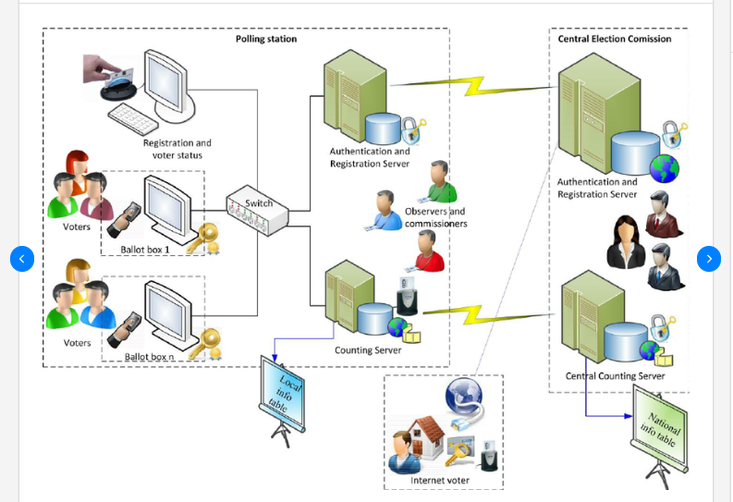

**6. PROJECT PLANNING & SCHEDULING:**

**6.1 Technical Architecture:**

This section provides some background information on electronic voting methods. Electronic voting is a voting technique in which votes are recorded or counted using electronic equipment. Electronic voting is usually defined as voting that is supported by some electronic hardware and software. Such regularities should be competent in supporting/implementing various functions, ranging from election setup through vote storage. Kiosks at election offices, laptops, and, more recently, mobile devices are all examples of system types. Voter registration, authentication, voting, and tallying must be incorporated in the electronic voting systems

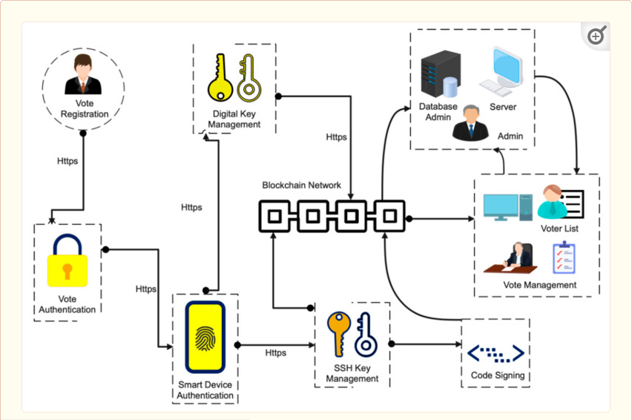

**6.2 Sprint Planning & Estimation:**

The focus of the sprint planning meeting is to set and agree upon the sprint goal–the amount of work the team believes it can complete during the sprint. The product owner, scrum master, and the full development team all need to be in attendance. At Atlassian, we recommend a minimum of one hour for each week of the sprint that you plan to cover in the meeting. For example, start with a two-hour sprint planning meeting to cover a two-week sprint. Ideally, schedule sprint planning early in the week. Then the team’s context and flow is disrupted less by the weekend.

At the start of the meeting, the scrum master presents any relevant action items from the team’s retrospective. Next, the product owner give product or market updates so everyone is on the same page and has the broader context fresh in their minds.

After the debriefs, it’s the product owner’s responsibility to start the actual planning conversation. To get started, the product owner uses the team’s average velocity (the amount of work typically completed in a sprint) to compile a suggested set of stories for the sprint, called the “sprint forecast”, that maximizes value to the customer. The product owner should also consider these three factors:

**6.3 Sprint Delivery Schedule:**

For a small number of users, blockchain works well. However, when the network is utilized for large-scale elections, the number of users increases, resulting in a higher cost and time consumption for consuming the transaction. Scalability problems are exacerbated by the growing number of nodes in the blockchain network. In the election situation, the system’s scalability is already a significant issue [[87](https://www.ncbi.nlm.nih.gov/pmc/articles/PMC8434614/#B87-sensors-21-05874)]. An electronic voting integration will further impact the system’s scalability based on blockchain [[88](https://www.ncbi.nlm.nih.gov/pmc/articles/PMC8434614/#B88-sensors-21-05874),[89](https://www.ncbi.nlm.nih.gov/pmc/articles/PMC8434614/" \l "B89-sensors-21-05874)]. [Table 3](https://www.ncbi.nlm.nih.gov/pmc/articles/PMC8434614/table/sensors-21-05874-t003/) elucidates different metrics or properties inherent to all blockchain frameworks and presents a comparative analysis of some blockchain-based platforms such as Bitcoin, Ethereum, Hyperledger Fabric, Litecoin, Ripple, Dogecoin, Peercoin, etc. One way to enhance blockchain scaling would be to parallelize them, which is called sharding. In a conventional blockchain network, transactions and blocks are verified by all the participating nodes

1. **CODING & SOLUTIONING (Explain the features added in the project along with code)**

## Security

Security measures guarantee the integrity and fairness of the voting process. Therefore, security should be a key concern of Internet voting systems. Not only does a robust security infrastructure protect the secrecy of ballots, but it also prevents ill-natured third parties from committing election fraud. In a [secure voting system](https://option.vote/voting-features/), the personal data of every participant is kept safe via encryption.

The following key security features should be included in a secure online voting system:

* **Confidentiality and encryption of data:** Encryption is the process of safeguarding information using mathematical techniques, making it inaccessible to anyone who doesn’t have the appropriate credentials. Online voting system data must be hosted on servers secured with the use of encryption and constant monitoring.
* **Secure connections:** Just as encryption improves the safety of servers, this process must also be implemented on Internet connections. If security protocols are put in place, the data flowing between nodes will be shielded from potential threats.
* **Integrity of the ballot:** Since confidentiality guarantees the authenticity of elections, the ideal online voting system must keep every single vote anonymous. Nonetheless, individual ballots and all user interactions with the voting system must be logged, archived, and meticulously monitored. This is particularly important to ensure a transparent auditing process. The election results should only be generated on demand, after passing a double authentication process. These should only be accessible by authorized persons, or those pre-identified by the organization. Every election participant using the system should be provided with a confidentiality/non-disclosure charter to use the software.
* **Blocking of fraudulent access:** Blockages are implemented to prevent Denial-of-Service (DoS) attacks on the server. Since DoS attacks are one of the most effective methods hackers use to compromise an undefended system, the addition of defensive.

**7.1 Feature 1**

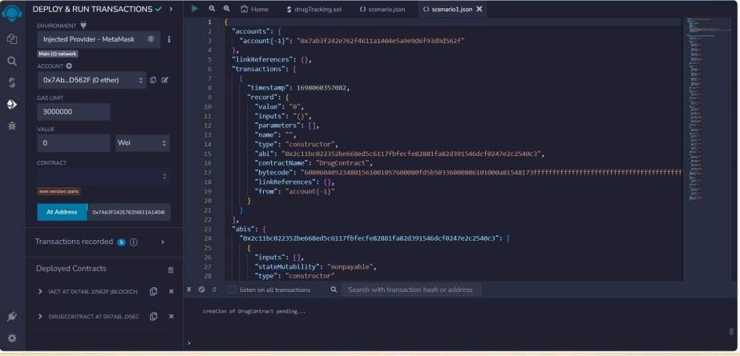

* 1. **Feature 2**



**7.3 Database Schema (if Applicable):**

Proper voting management requires that every voter confirms their identity. During a traditional presidential election, for example, it is customary for voters to provide some form of ID during registration or at their polling station. Online elections are similar in that regard, as member verification is crucial to prevent election fraud and give voters a satisfactory electoral experience.

The most sophisticated identification features used by [Internet voting systems](https://option.vote/voting-features/) use a multi-verification solution. By using data encryption methods in tandem with unique member PINS, user data is kept in a system akin to a virtual bank vault. Individual voters can access electronic ballots with the same ease as logging into social media, while the system architecture keeps their data functional and safe.

**8. PERFORMANCE TESTING**

**8.1 Performace Metrics**

The revised Standards provide new or expanded coverage of the following functional and technical system capabilities:

• Election Management Functions: Performance requirements are specified for components that define, develop and maintain election databases; perform election definition and setup functions; format ballots; count votes; consolidate and report results; and maintain audit trails.

• Feedback to Voter: Performance requirements are defined for DRE systems and for paper-based precinct-based systems in order to provide direct feedback to the voter that indicates when an undervote or overvote is detected.

• Accessibility: Performance requirements are defined for voting systems so that a system can meet the specific needs of voters with disabilities. These requirements were developed by the Access Board, a federal agency responsible for developing accessibility standards. The requirements are based on the accessibility standards for electronic and information technology established in 36 CFR Part 1194 - Electronic and Information Technology Accessibility Standards, which implement Section 508 of the Rehabilitation Act Amendments of 1998. The requirements provide common standards that must be met by all voting devices claiming accessibility and specific standards related to various types of DRE voting systems.

• Audit Trails: Performance requirements for audit trails are strengthened to address the full range of election management functions, including such functions such as ballot definition and election programming.

• Telecommunications: Performance requirements are defined for hardware and software components of voting systems that transmit voting-related information using public telecommunications components. These requirements apply to systems where data is carried between devices at a single site, and systems where data is carried between devices in two geographically distinct locations. Systems must be designed to provide the secure transfer of many distinct types of vote data, including lists of eligible voters, voter authentication information, ballot definition information, and vote transmission and **RESULTS:**

The following businesses and organizations, founded but mainly formed over the last five years, are developing the voting sector. All share a strong vision for the blockchain network to put transparency into practice the different online platforms, their consensus, and the technology used to develop the system. Currently available blockchain-based voting systems have scalability issues. These systems can be used on a small scale. Still, their systems are not efficient for the national level to handle millions of transactions because they use current blockchain frameworks such as Bitcoin, Ethereum, Hyperledger Fabric, etc.

In we present scalability analysis of famous blockchain platforms. The scalability issue arises with blockchain value suggestions; therefore, altering blockchain settings cannot be easily increased. To scale a blockchain, it is insufficient to increase the block size or lower the block time by lowering the hash complexity. By each approach, the scaling capability hits a limit before it can achieve the transactions needed to compete with companies such as Visa, which manages an average of 150 million transactions per day. Research released by Tata Communications in 2018 has shown that 44% of the companies used.

**9.1 Output Screenshots:**

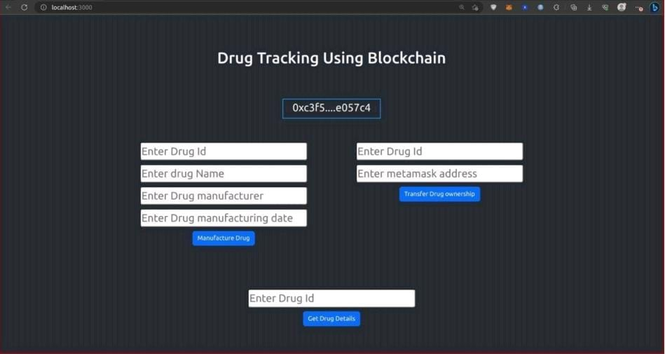

1. **ADVANTAGES & DISADVANTAGES:**

**ADVANTAGE:**

The advantages of online voting systems include increased efficiency, improved accuracy, and greater voter engagement compared to paper ballots.

**Increased Efficiency**

One of the most significant advantages of online voting systems is incredible efficiency. With traditional paper-based voting, there are a lot of steps involved, from printing ballots to counting votes by hand. You can avoid all of that with online voting.

With an online system, you can send out electronic ballots to all of your voters in just a few clicks. And once the voting period is over, the system will automatically tally the results, so you don't have to do it yourself, saving your organization a lot of time and money.

**Improved Accuracy**

Another advantage of online voting systems is that they tend to be more accurate than traditional paper-based systems. On the other hand, there's always the potential for human error with paper ballots, whether it's miscounting votes or mixing up ballots.But with an online voting system, the votes are tallied automatically, so there's no chance for human error, giving you peace of mind knowing that your results are accurate.

Greater Turnout And Voter Engagement

Another advantage of online voting is that it can increase voter turnout because it's more convenient for voters to cast their ballots online than to have to go to a physical polling place.

In addition, online elections can also improve voter engagement. It can be easy for voters to feel disconnected from the process of traditional voting. But with online voting, they can see the results in real-time, making them feel more engaged in the process.

**DISADVANTAGE:**

The Security Of Online Voting Systems

One of the most significant disadvantages of online voting systems is that they're not as secure as traditional paper-based systems because there's always the potential for hackers to tamper with the results.

To improve election security, you should look for a system that uses encryption to protect the data. The system must get tested by independent security experts.

For example, we secure our online voting system using 256-bit encryption—the same level of security that major banks offer. Plus, we don't share user and voter data, which means your elections stay private and confidential.

Lack Of Transparency

Another disadvantage of online voting is that it can lack transparency. With traditional paper-based voting, voters can see people counting the ballots. But with online voting, the process is entirely electronic, making it harder to verify the results.

It’s essential to look for an online voting system that offers transparency features. For example, some systems provide a live election results page where voters can see the results as they roll in.

Our voting system also offers election audit, which means the votes cast using our system are auditable. We also provide independent verification, where an independent, third-party accountant ensures the election process is fair.

**11. CONCLUSION:**

The goal of this research is to analyze and evaluate current research on blockchain-based electronic voting systems. The article discusses recent electronic voting research using blockchain technology. The blockchain concept and its uses are presented first, followed by existing electronic voting systems. Then, a set of deficiencies in existing electronic voting systems are identified and addressed. The blockchain’s potential is fundamental to enhance electronic voting, current solutions for blockchain-based electronic voting, and possible research paths on blockchain-based electronic voting systems. Numerous experts believe that blockchain may be a good fit for a decentralized electronic voting system.

Furthermore, all voters and impartial observers may see the voting records kept in these suggested systems. On the other hand, researchers discovered that most publications on blockchain-based electronic voting identified and addressed similar issues. There have been many study gaps in electronic voting that need to be addressed in future studies. Scalability attacks, lack of transparency, reliance on untrustworthy systems, and resistance to compulsion are all potential drawbacks that must be addressed. As further research is required, we are not entirely aware of all the risks connected with the security and scalability of blockchain-based electronic voting systems.

Adopting blockchain voting methods may expose users to unforeseen security risks and flaws. Blockchain technologies require a more sophisticated software architecture as well as managerial expertise. The above-mentioned crucial concerns should be addressed in more depth during actual voting procedures, based on experience. As a result, electronic voting systems should initially be implemented in limited pilot areas before being expanded. Many security flaws still exist in the internet and polling machines. Electronic voting over a secure and dependable internet will need substantial security improvements. Despite its appearance as an ideal solution, the blockchain system could not wholly address the voting system’s issues due to these flaws. This research revealed that blockchain systems raised difficulties that needed to be addressed and that there are still many technical challenges. That is why it is crucial to understand that blockchain-based technology is still in its infancy as an electronic voting option.

**12. FUTURE SCOPE:**

Generally, the scope of the VVSG Version 2.0 will continue to cover the ability to perform prevoting, voting, and post-voting operations. The primary difference, however, is that instead of creating guidelines based on the system or device, the VVSG will describe all of the functions that are incorporated in a device or devices that make up a system. A summary of the principles of a voting system and the guidelines for each of the functions is listed below. The Help America Vote Act of 2002, Section 301 (b) defines a voting system as “the total combination of mechanical, electromechanical, or electronic equipment (including the software, firmware, and documentation required to program, control and support the equipment that is used to define ballots; to cast and count votes; to report or display election results; and to maintain and produce any audit trail information.” In order to provide an outline for how the structure of the VVSG Version 2.0 will be written, the presentation of the Scope of a voting system is depicted using the Principle and Guideline structure.

**13. APPENDIX:**

**Video Demo Link: https://youtu.be/q1K8IPyRXVw?si=NnltyZgWUp0eHOwW**